PERCEPTION ON JOB CREATION IN UGANDA AND GHANA

The intention of this article seeks to generate findings based on the data analysis carried on the Afrobarometer survey. Reasons for choosing Uganda and Ghana was influenced by the extent of their democracy, where Ghana was more democratic than Uganda. As the survey has 2,400 observations, the aim is to investigate whether these findings are representative of the population mean, thus referring to their respective countries. Hence the objective of this article was to investigate the perceptions of education towards party job creation.
DATA COLLECTION & PROCESSING
The data was extracted from the merged round 6 survey using the statistical programming language of R. The selected questions included the following:
- Q97- This discussed the level of education.
- Q63B- This focused on the perceptions by the participants regarding their views towards the ability of a party to create jobs.
DATA PROCESSING
As the survey data is primarily classified as categorical and discrete. Therefore, the author intended to do an analysis. In terms of levels of education, they were divided into three categories uneducated, less educated, and more educated. This was influenced by the structure of the responses as further outlined in the R script. For the perception regarding party creation, the paper generated two outcomes which are Ruling and Opposition Parties. In processing the data, the primary intention of the paper was to generate graphs to visualize the findings and understand the distribution of the values in a better way.
DATA VISUALIZATION
For data visuals, the investigation made use of the ggplot2 package in R which generates good visualizations.

  - UGANDA
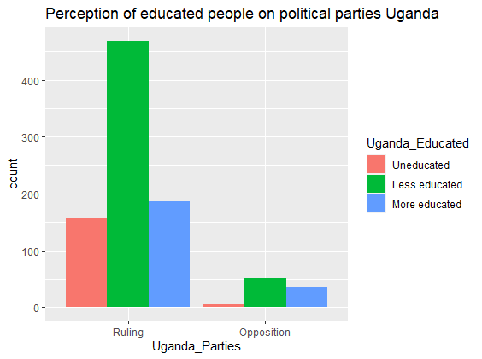

The above graph highlights the perceptions of the Ugandan people and their perceptions of job creation on political parties. As deduced from above, the respondents from the round 6 sample highlight that they view the ruling party as capable of creating more jobs than the opposition party. In addition, most of these people are less educated and looking at all the education criteria, the respondents who participated were for the ruling party as to the opposition.

  - GHANA
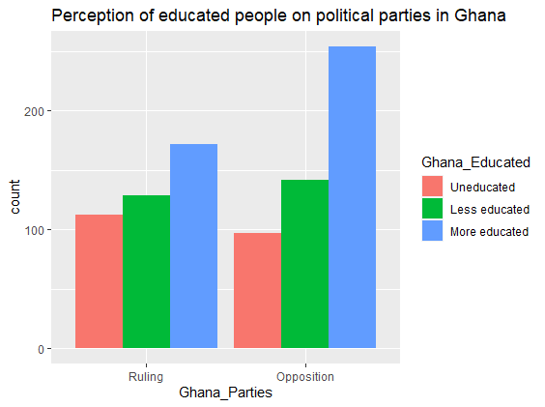
The Ghana information defers from that of Uganda. From the above diagram, the respondents perceive the opposition as more capable of creating jobs than the ruling party. The respondents from this survey have a higher concentration of educated people than those in Uganda who completed advanced high school and university level.

  - STANDARD ERROR OF THE MEAN
Despite there being graphs, statistical analysis is important to measure the reliability and validity of the data. Hence from these two countries, the survey of 2,400 respondents can be argued to be a sample mean of the population. In this case, the population is the number of educated adults who are perceived to be at the legal age to vote in both countries. The analysis was carried in R as more information can be found in the R-Script file.
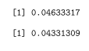
The above picture shows the calculated standard error of the sample means in Uganda and Ghana, respectively. Hence Uganda has 0.046 whilst Ghana carries 0.043. The conclusion regarding this is that both countries have a low standard error of the sample mean and one may state that they are representative of the population mean.

  - CONCLUSION
With results indicating more respondents in Uganda who viewed the ruling party as capable of job creation as to Ghana where most respondents perceived the opposition party as capable of job creation. In the future, more data could be extracted and analysed regarding this matter, overall, it also highlights from a political perspective that the ruling party has a strong foothold in Uganda than in Ghana. Also, from a governance point of view, it suggests that Ghana has more educated people than Uganda and this further throws in the assumption that there is a higher probability the human development index is better in Ghana than in Uganda, based on this data.

